Git: Assignment 2

By Kenneth Mallabo

Last Updated: 08/12/2022

# Setting Up GitHub Repo

Public Repository link: <https://github.com/ZINAHAL/os_test>

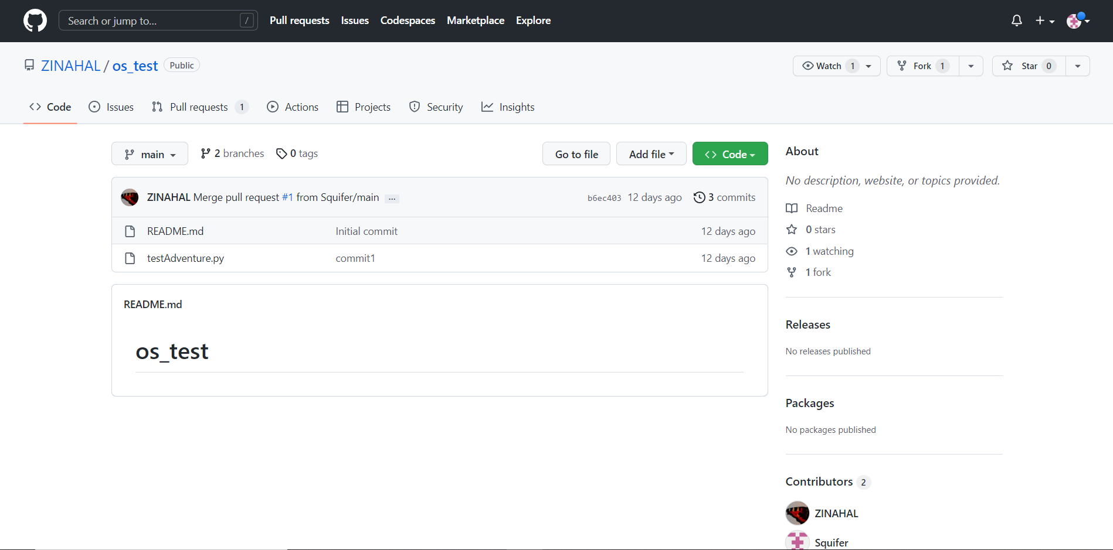

# What is GitHub

GitHub is a cloud-based Git repository hosting service which helps it easier for people to use the Git open-source version control system and allow collaboration with others to work on projects anywhere. Git by itself is relatively not user friendly as it requires using the command line but GitHub’s GUI allows many more people to use it comfortably. Creating a repository and hosting the public codebase is completely free which the reason for GitHub’s success with open-source projects.

# Branching & Merging

Branching is the way that GitHub manages version control. It is recommended that before performing a push request to the main/default branch, you should instead create a new branch and push that new version of the code so as to make sure that the new changes be contained for now. If the author finds the changes satisfactory, then the author may allow a merge between the two branches.

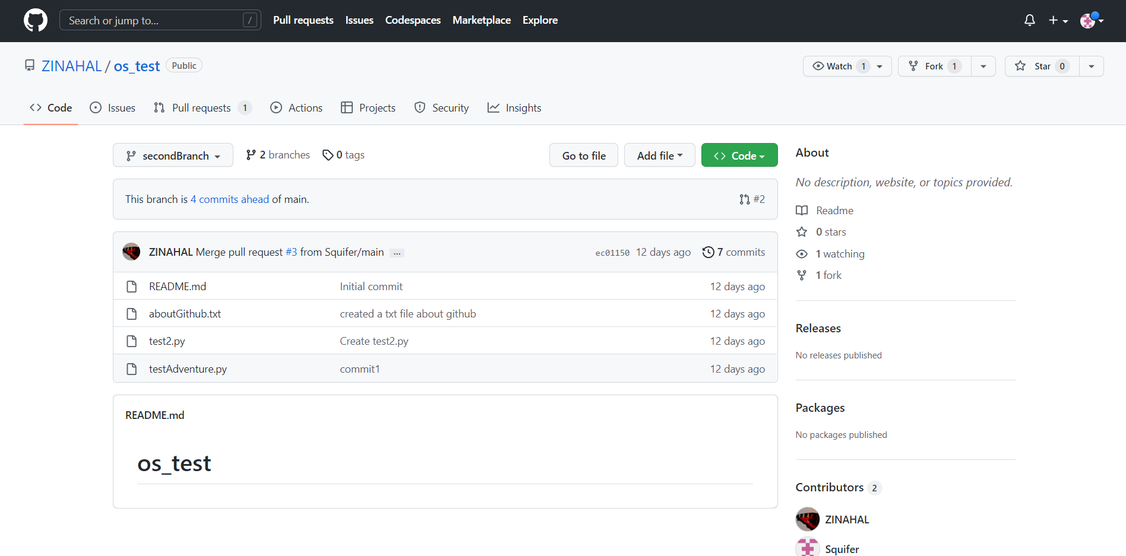

# Clone vs Fork

If the user does not have access to someone else’s GitHub repository, then the user cannot add modifications to that repository. The work around to this is using a fork which is to make a copy of a repository. You can then make your project based on their repository. This can only be performed on GitHub by pressing the “Fork” button on the desired repository and not on Git’s command lines.

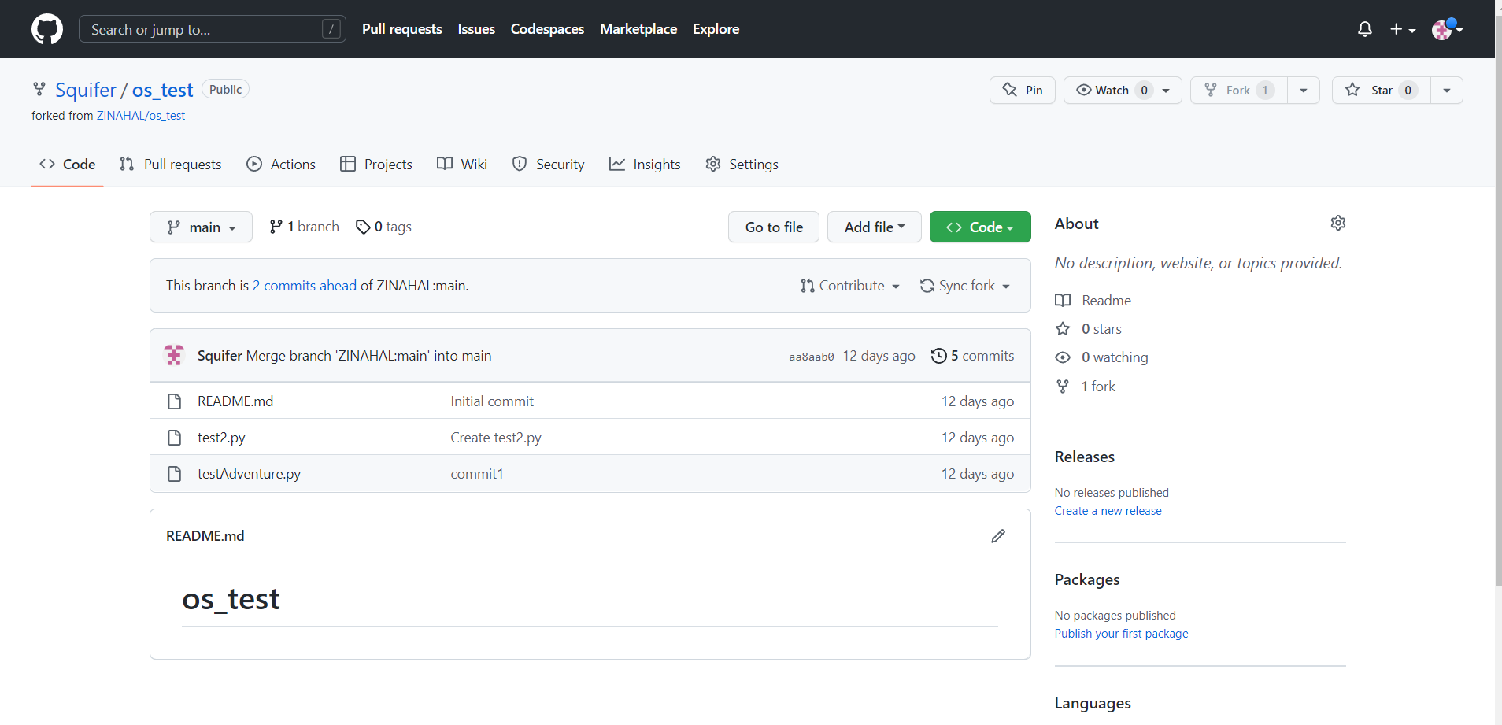

With this fork, it is now possible retrieve that forked repository by using the clone command into your own local Git. Click on the green “Code” button to get the URL for the clone command line.

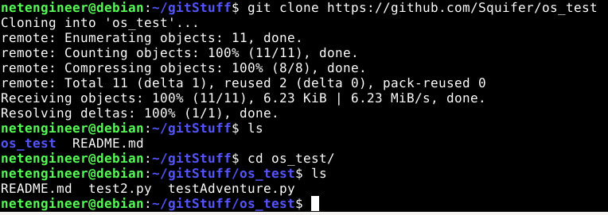

# Push

Once changes are made in the local git, in order to update the repository using the command “git commit -a” to stage all of the files. Then use the command “git push origin” would then attempt for the local repository to push the new changes to the forked repository.

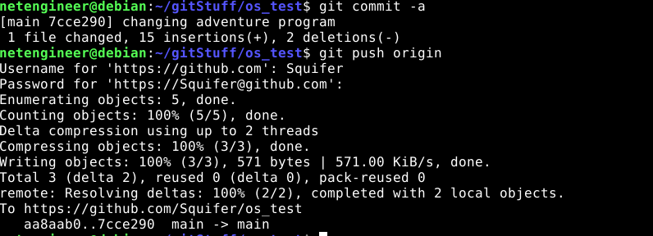

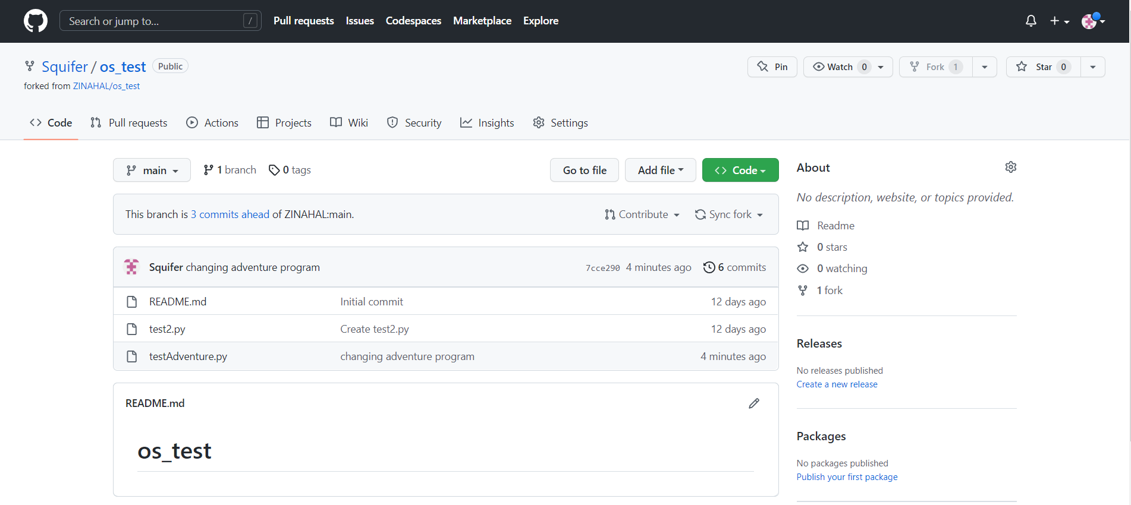

# Pull request

Once the changes the were made in the forked repository, we send a pull request to the original repository in order to commit our changes. Click the “Contribute” button and then the “Open pull request”.

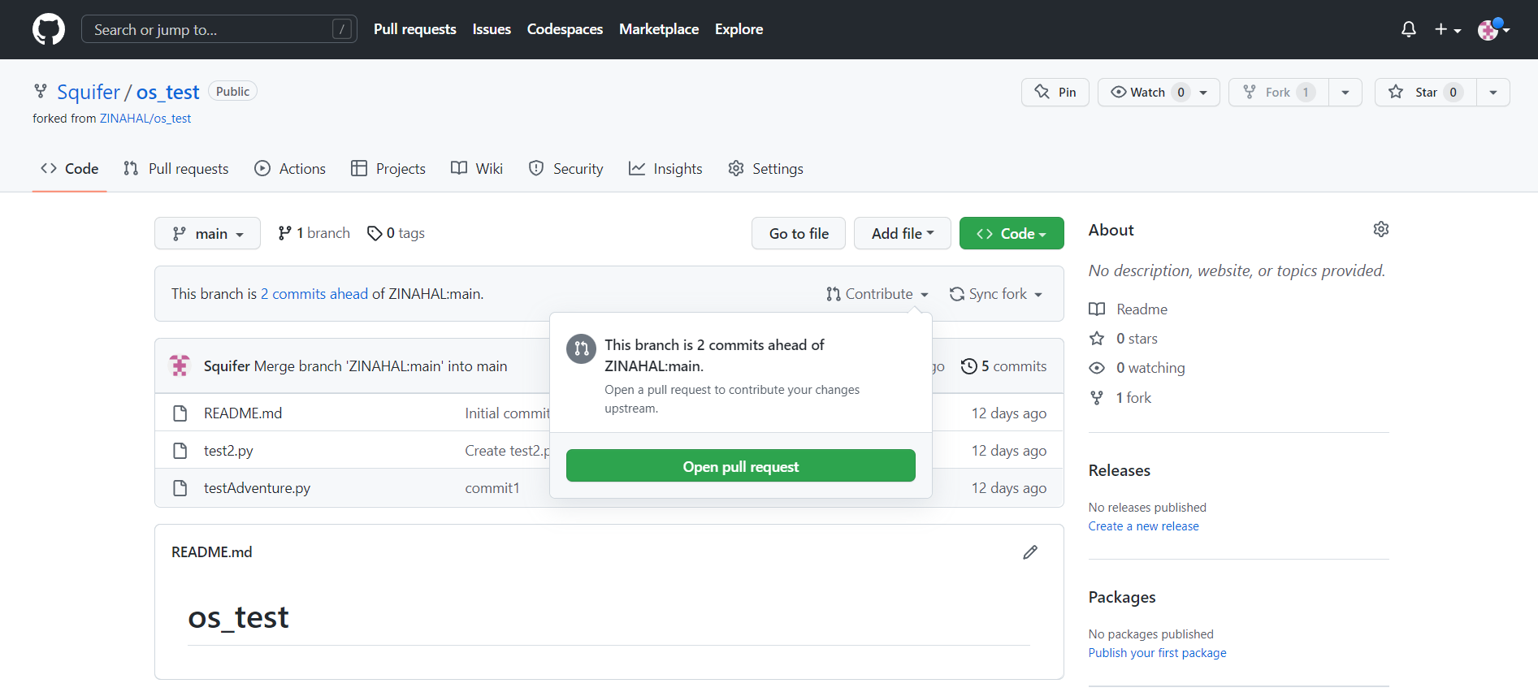

Then add a message for the title and finally click “Create pull request”.

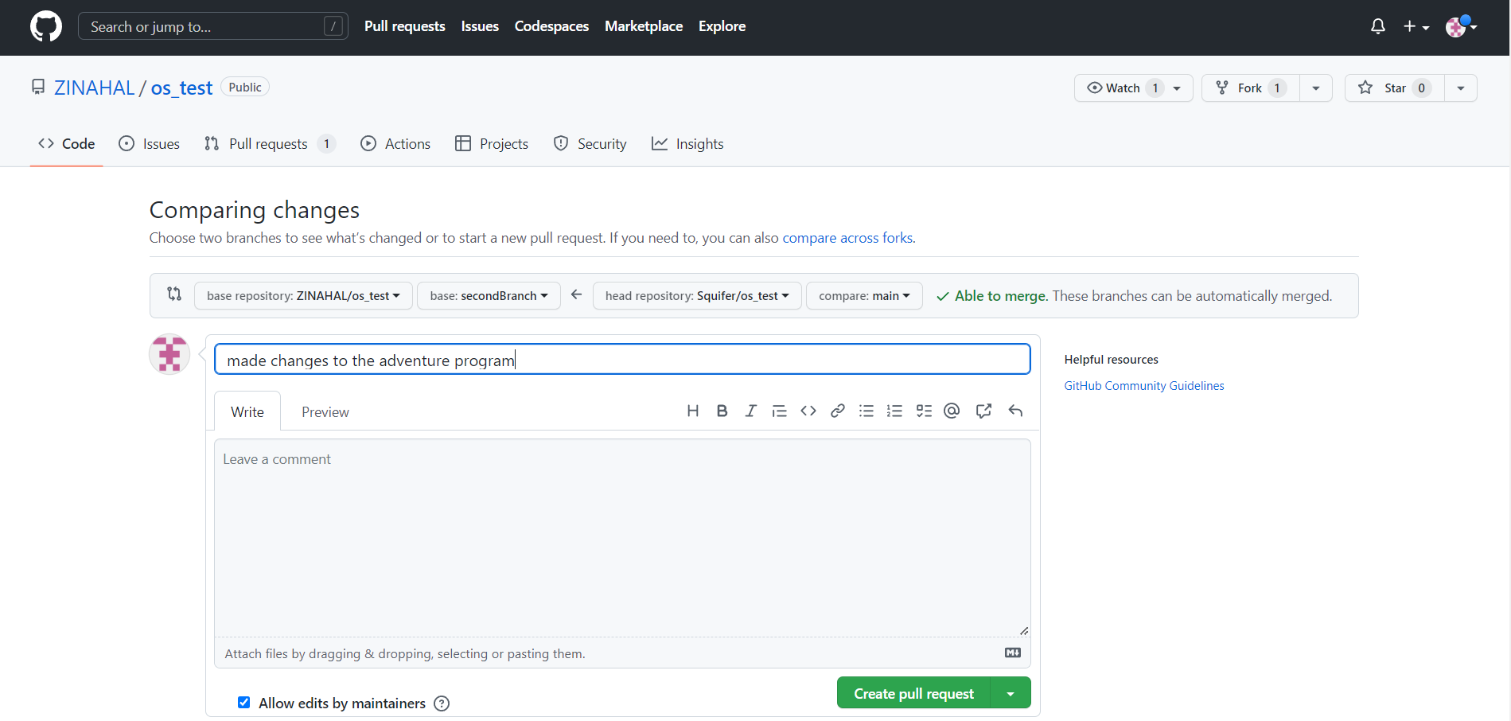

It will then show if there were conflicts with the original branch.

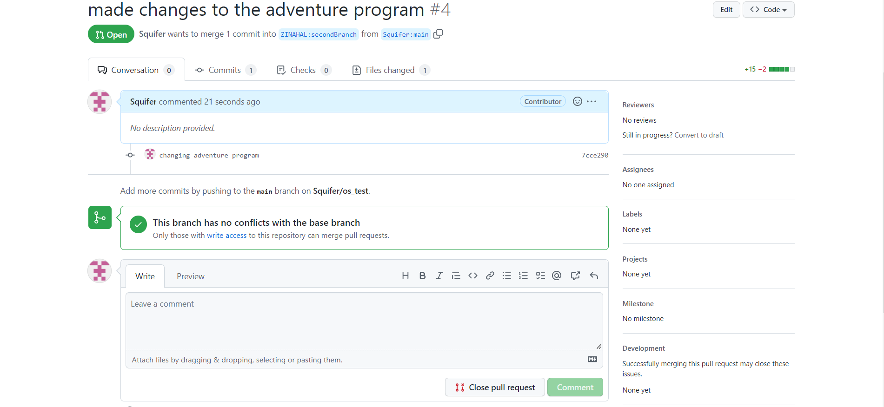

# Merge conflicts

If there were merge conflicts with the original branch then it must mean that there were already changes made in the original branch from the time that we have forked the repository to perhaps just before we sent the pull request. One way to solve this is to make sync our forked repository from the original branch and then add our changes to send another pull request.

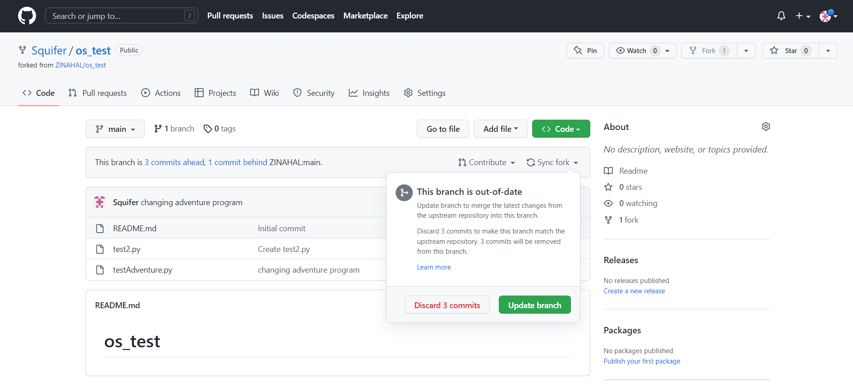

# User Management

To add users as collaborators in order for others to make contributions, the user must go to “Settings” and then “Collaborators”. Press “Add people” and then add their username, full name or email to invite them.

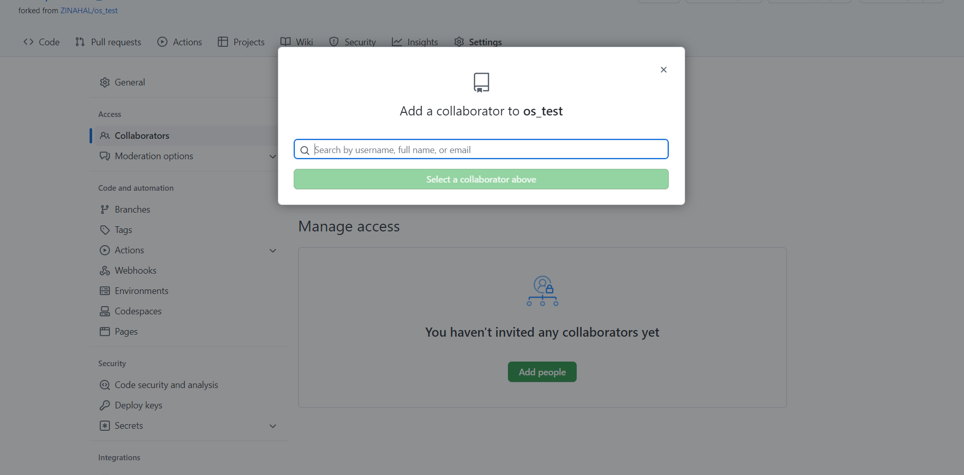

It is also possible enable temporary restrictions to types of users as shown in the image below.

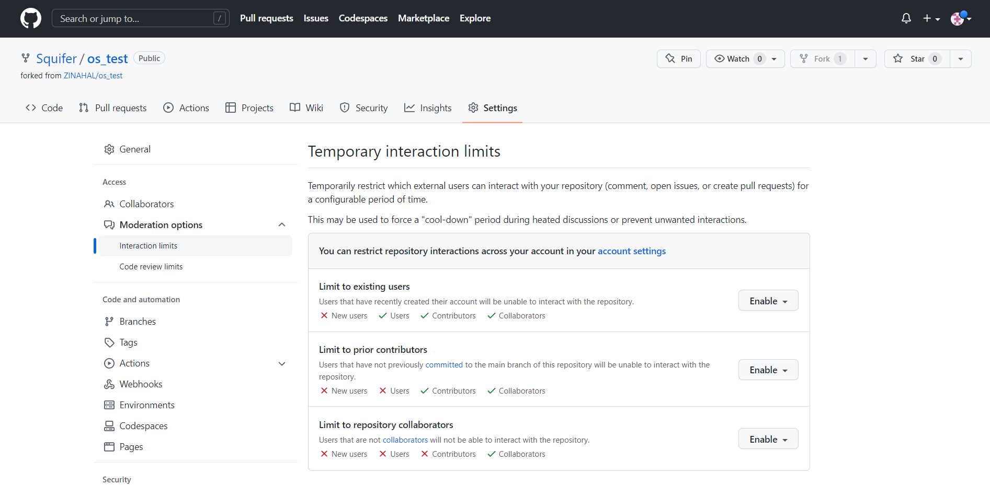

Another type of restriction exist for code reviews on certain types of users as shown in the image below.

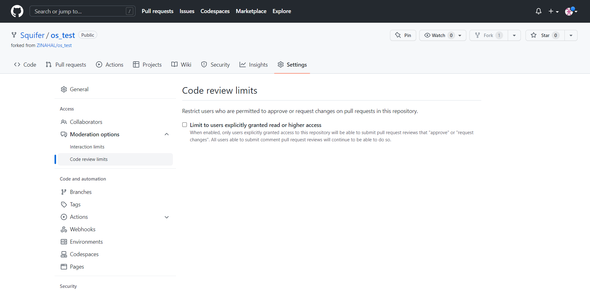

# References

Kinsta. (2022). *What Is GitHub? A Beginner’s Introduction to GitHub* [online]. Available from:<https://kinsta.com/knowledgebase/what-is-github/> [accessed 7 December 2022].

W3schools. (n.d.). *Git Tutorial* [online]. Available from: <https://www.w3schools.com/git/default.asp?remote=github> [accessed 7 December 2022].